VA-013 — Insufficient File Type Validation
Finding ID | VA-013
Severity | Low
CVSS v3.1 Score | 3.7 (MEDIUM)  (CVSS:3.1/AV:N/AC:L/PR:L/UI:N/S:U/C:L/I:L/A:N)
Assessment Type | DAST
Affected Asset / Component | https://nibterachatboat.nibbank.com.et/admin
CWE Reference | CWE-434: Unrestricted Upload of File with Dangerous Type  CWE-20: Improper Input Validation
CVE Reference | N/A
Status | Open
Description
The image upload functionality does not enforce adequate server-side validation of uploaded file types, the application accepted multiple non-image file formats, including HTML, PDF, and Microsoft Excel files, despite the feature being intended solely for image uploads.
The acceptance of unsupported file formats indicates insufficient validation of file extensions, MIME types, and file content signatures.

Evidence / Proof of Concept
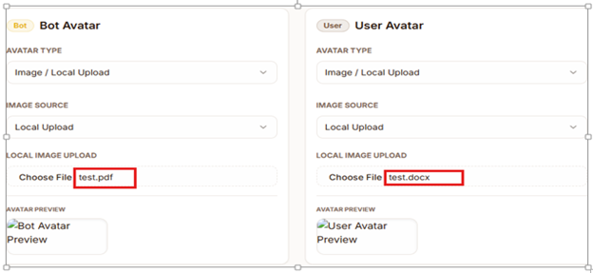
Impact
Failure to properly validate uploaded file types increases the application's attack surface and may allow attackers to upload unauthorized content to the server.
Potential risks include:
• Storage of unintended file types.
• Upload of malicious content disguised as legitimate files.
• Client-side attacks if uploaded HTML files are rendered by users' browsers.
• Increased likelihood of exploitation if additional file handling weaknesses exist.
• Abuse of server storage resources through unrestricted content uploads.

Recommendation
• Implement strict server-side validation of uploaded file types.
• Use an allowlist approach and permit only approved image formats.
• Validate file extensions, MIME types, and file signatures (magic bytes).
• Reject files that do not match approved image formats.

VA-014 — Internal Application Data Stored in Browser Local Storage
Finding ID | VA-014
Severity | Low
CVSS v3.1 Score | 3.7 (Low)  CVSS:3.1/AV:N/AC:H/PR:N/UI:R/S:U/C:L/I:N/A:N
Assessment Type | DAST
Affected Asset / Component | nibterachatboat.nibbank.com.et
CWE Reference | N/A
CVE Reference | N/A
Status | Open
Description
The application stores internal application data and workflow-related information within the browser's Local Storage. Multiple entries containing user session identifiers, menu draft information, report draft data, editing status, assignment details, and workflow metadata were observed.
Because Local Storage is accessible through client-side JavaScript, any successful Cross-Site Scripting (XSS) attack or local browser compromise could expose the stored information.
Evidence / Proof of Concept
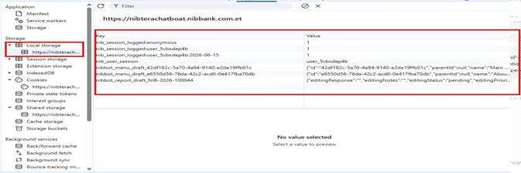
Impact
The exposure of internal application metadata may assist attackers in understanding business processes, workflow states, and application structure. Additionally, storing workflow-related information on the client side increases the risk of unauthorized disclosure if browser storage is accessed by malicious scripts.
- Although no authentication tokens, passwords, or sensitive customer data were identified, unnecessary storage of internal operational data increases the application's attack surface.
Recommendation
• Avoid storing internal workflow and operational metadata in browser Local Storage unless strictly required.
• Store only non-sensitive client-side cache data.
• Ensure workflow states, approval status, assignments, and authorization decisions are enforced and validated exclusively on the server side.
• Periodically review browser storage usage and remove unnecessary data.
• Consider implementing Content Security Policy (CSP) and other XSS protections to reduce the risk of Local Storage exposure..

Finding ID: VA-015-Vulnerable Nodemailer Dependency
Severity: High
CVSS v3.1 Score: 8.1 (High)
Assessment Type: SCA (Software Composition Analysis)
Affected Asset / Component: nodemailer npm package
CWE Reference: CWE-552 – Files or Directories Accessible to External Parties, CWE-918 – Server-Side Request Forgery (SSRF)
Description:
The application contains a vulnerable version of Nodemailer (≤ 9.0.0). A security advisory indicates that the message-level raw option can bypass the disableFileAccess and disableUrlAccess security controls, potentially allowing unauthorized file access and Server-Side Request Forgery (SSRF) under specific conditions.
Evidence:
nodemailer <= 9.0.0
Impact:
If attacker-controlled input can influence email message construction, an attacker may be able to read local files or force the server to make requests to internal or external resources. This could result in sensitive information disclosure and unauthorized network access.
Recommendation:
Upgrade Nodemailer to version 9.0.1 or later. Review application logic to ensure user-controlled input cannot influence raw email content or message configuration options.

Finding ID: VA-016 - Vulnerable undici Dependency
Severity: High
CVSS v3.1 Score: 8.1 (High)
Assessment Type: SCA (Software Composition Analysis)
Affected Asset / Component: undici npm package
CWE Reference: CWE-295 – Improper Certificate Validation, CWE-200 – Exposure of Sensitive Information to an Unauthorized Actor
Description:
The application contains a vulnerable version of the undici HTTP client library (7.0.0–7.27.2). Publicly disclosed vulnerabilities include TLS certificate validation bypass in SOCKS5 ProxyAgent implementations and cross-user information disclosure through cache isolation weaknesses.
Evidence:
undici 7.0.0 - 7.27.2
Impact:
Successful exploitation could allow attackers to bypass TLS certificate validation when proxy connections are used, increasing the risk of man-in-the-middle attacks. Additionally, cache isolation weaknesses may result in unintended disclosure of data between users.
Recommendation:
Upgrade undici to the latest supported version that addresses the identified vulnerabilities. Review proxy configurations, certificate validation settings, and caching implementations to ensure secure operation.

VA-017 – Weak Authentication Rate Limiting Controls
Severity: High
CVSS v3.1: 8.1 (High) – CVSS:3.1/AV:N/AC:L/PR:N/UI:N/S:U/C:H/I:H/A:L
Assessment Type: DAST
OWASP Category: A07:2021 – Identification and Authentication Failures
Description
The application does not implement adequate controls to restrict repeated authentication attempts. During testing, multiple login requests were submitted using different usernames and a common password through an automated process. The application processed these requests without enforcing account lockout, CAPTCHA verification, progressive delays, or rate-limiting mechanisms.
The absence of these controls increases the likelihood of successful credential-guessing and credential-stuffing attacks against user accounts.
Evidence
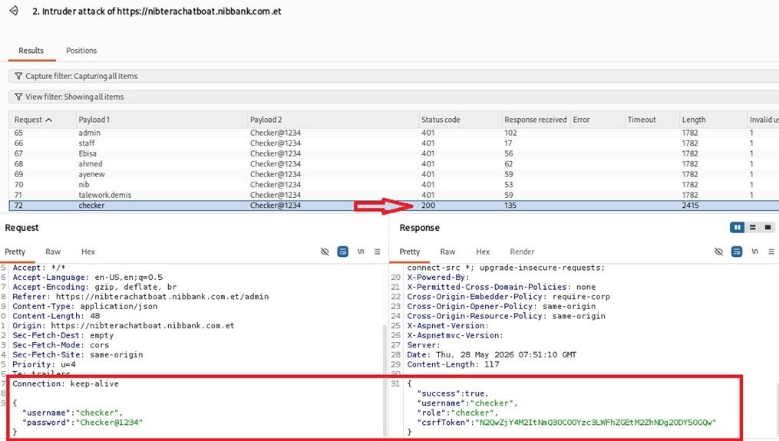
Impact
An attacker could automate authentication attempts against user accounts without significant restriction. This weakness increases the risk of unauthorized access through password-guessing and credential-stuffing attacks. Successful exploitation may lead to account compromise, unauthorized access to sensitive information, abuse of user privileges, and potential compromise of business operations.
Recommendation
Implement authentication protection mechanisms to detect and prevent automated login attempts. These controls should include account lockout after a defined number of failed login attempts, IP-based and account-based rate limiting, CAPTCHA or challenge-response mechanisms following repeated failures, and continuous monitoring of suspicious authentication activity.
.

Security Vulnerability Remediation Report
Security Vulnerability Remediation Report
This document outlines the responses and implemented solutions for the vulnerabilities identified in the recent security report.
1. Vulnerable Dependency: nodemailer (VA-015)
Implemented Solution:
- Upgraded nodemailer from ^8.0.9 to ^9.0.1.
- Resolved SSRF and file access bypass risks.
2. Vulnerable Dependency: undici (VA-016)
Implemented Solution:
- Upgraded undici from ^7.13.0 to ^7.28.0.
- Resolved TLS verification bypass risks.
3. Rate Limit Bypass via IP Spoofing (VA-017)
Implemented Solution:
- Added secure internal x-direct-client-ip header.
- Added TRUST_PROXY configuration.
- Reduced authentication rate limit to 10 attempts per 15 minutes.
- Added automated unit tests.
Status: Resolved.
4. Insufficient File Type Validation (VA-013)
Status: False Positive / Already Mitigated.
- MIME validation
- Extension whitelist
- Magic-byte verification
- Anti-malware scanning
- X-Content-Type-Options: nosniff
5. Internal Application Data Stored in Browser Local Storage (VA-014)
Status: Partially Present (Low Risk) / Mitigated.
- No sensitive data stored in localStorage.
- Drafts stored server-side.
- Audit logging disabled.
- Only non-sensitive telemetry identifier retained.
May be:

